

- 2026)
Dr. Jayaram Boga
L. Sainath
2520090148
CSIT
CO – 3 Graph Algorithms & Optimization Techniques

Case Study Topic: Tournament Management using Graph Algorithms
Work Done Summary:
In this case study, graph-based algorithms were used to model tournament structures and team relationships. Teams and matches were represented as graph vertices and edges. BFS and DFS were implemented to analyze tournament progression and connectivity. Minimum Spanning Tree (MST) algorithms were used to design efficient training and communication networks among teams.
Implementation Details:
- Represented teams and matches as graph structures.
- Implemented BFS to analyze tournament progression paths.
- Implemented DFS to explore team connectivity and detect cycles.
- Applied Kruskal's Algorithm to construct a Minimum Spanning Tree.
- Applied Prim's Algorithm for optimal network design.
- Evaluated graph traversal and MST performance for tournament management.

Result: Screenshot/Output

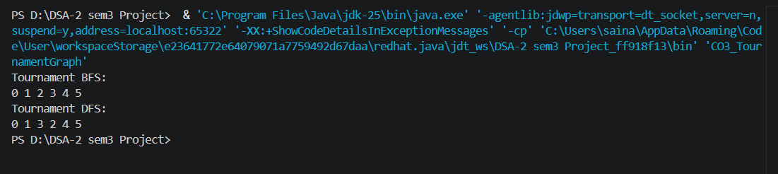

- Tournament progression paths were analyzed successfully.
- Team connectivity and relationship structures were identified.
- Efficient training network structures were generated using MST algorithms.
Time Complexity:
- BFS: O(V + E)
- DFS: O(V + E)
- Kruskal's Algorithm: O(E log E)
- Prim's Algorithm: O(E log V)

GitHub Link: https://github.com/Sainath5689/DSA-2-SEM3-PROJECT

